Go to client point and locate client ->
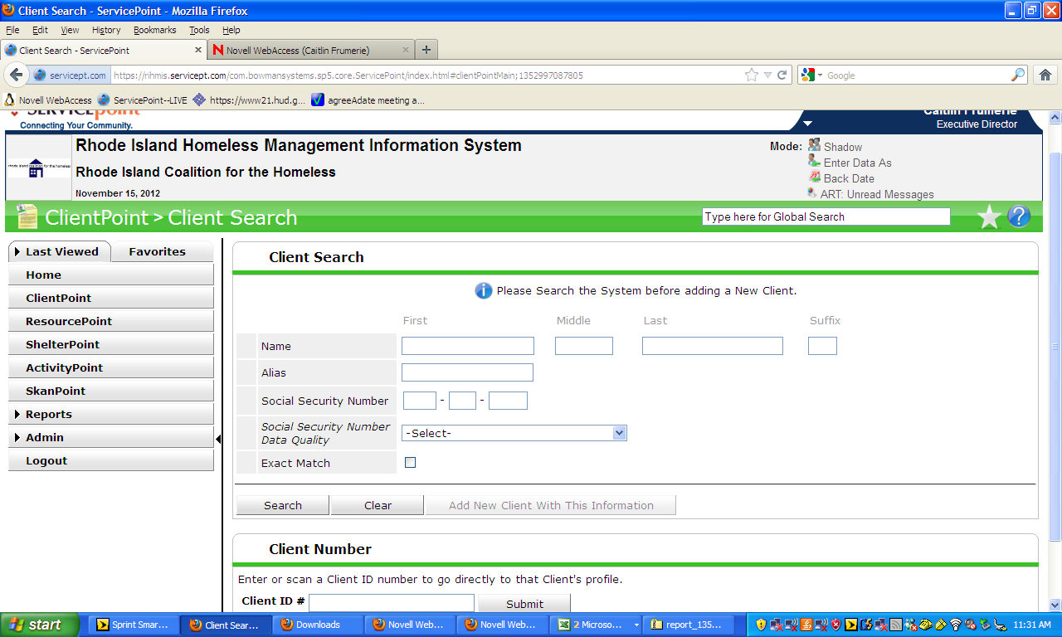

Open client record
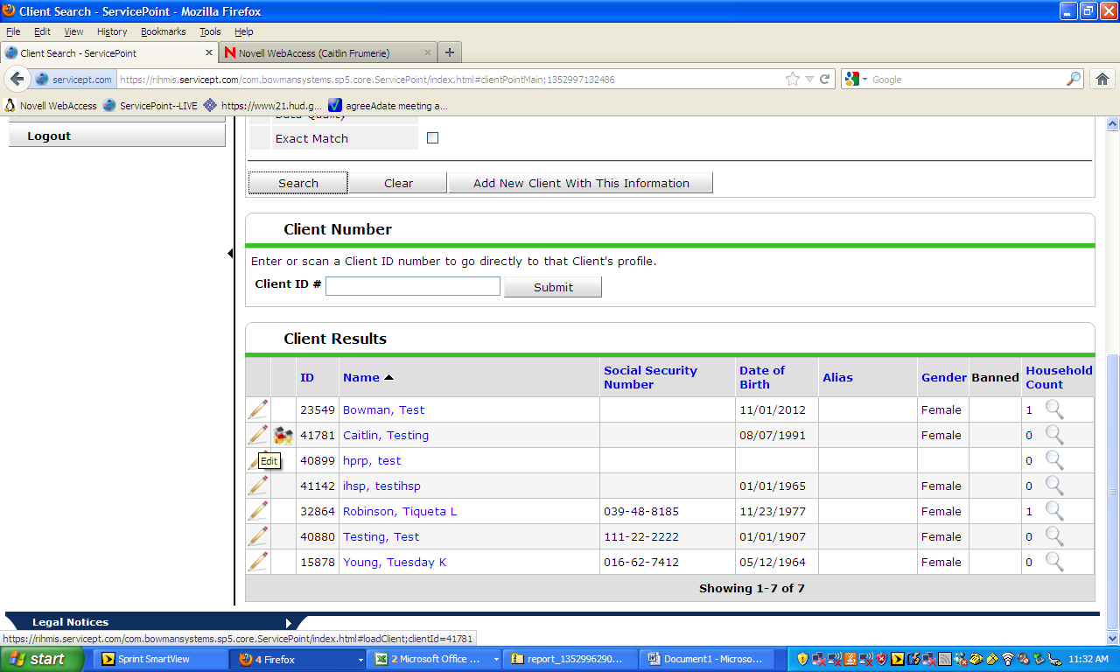

Stay on client summary page
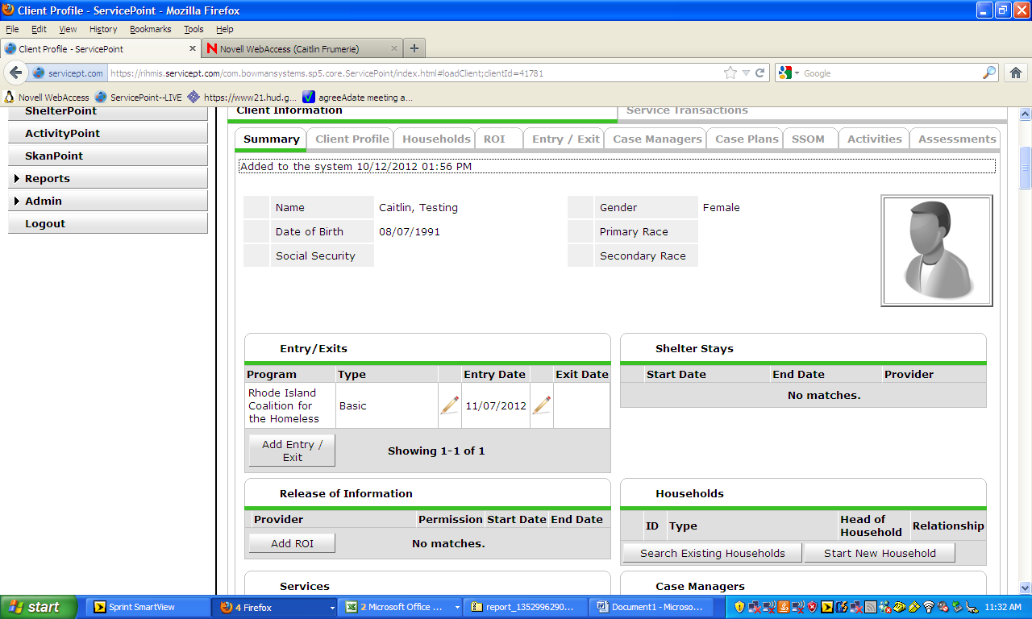

Review record to ensure it’s the right client
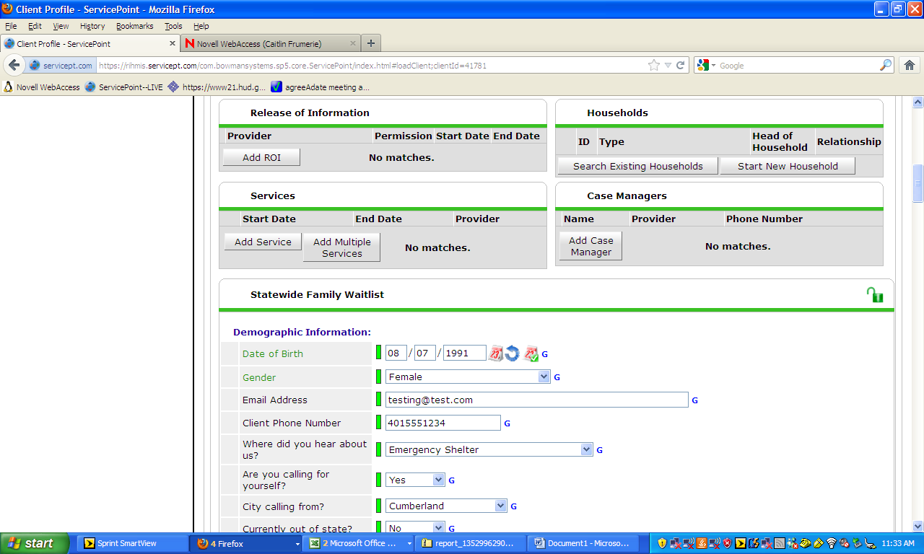

SCROLL DOWN TO BOTTOM OF SUMMARY PAGE

TO TAKE CLIENT OFF THE WAITLIST, answer the bottom TWO QUESTIONS:
“Still in need of shelter” AND “Shelter Going to”

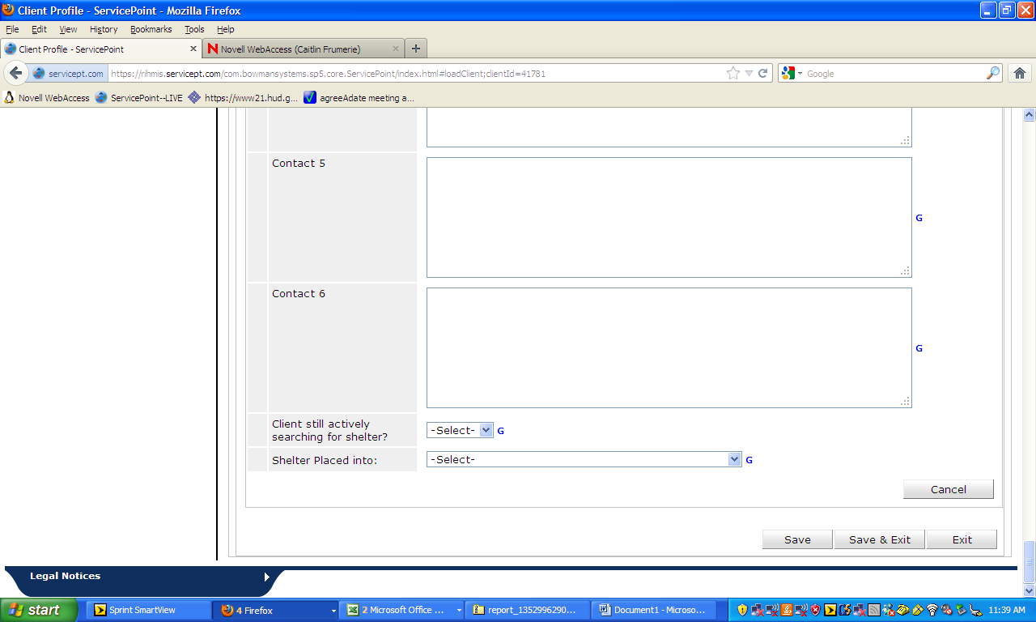
THEN PROCEED WITH NORMAL SHELTER ENTRY

